**Progress 2**

**Note(anything is highlighted by yellow is done .and the red once is partially done but not included in this report )**

**Required information in report**:

1. The results of this project include a visualization (sociograms) of the network which is a result of the combination of 2-3 case or 2-3 affiliation variables
2. Case-by-case matrices, affiliation-by-affiliation matrices and case-by-affiliation matrix
3. A discussion on the workings of the network
4. The density of the network
5. The points centrality of the network
6. A discussion of the components of the network, cliques stars, brokers, and influencers etc.

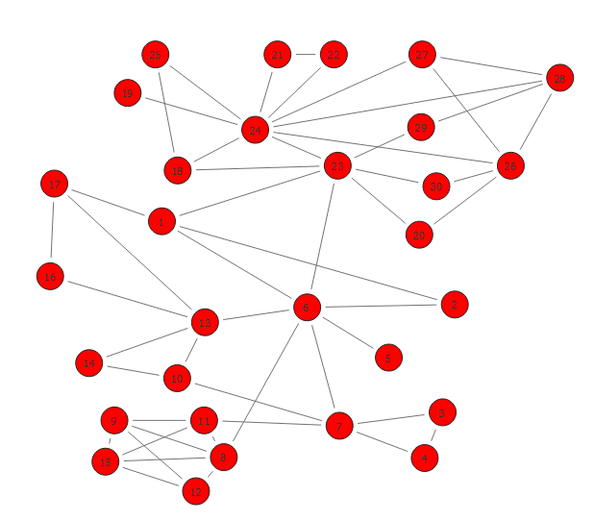

**Yokiko : 1**

**Yosako : 2**

**Shizako : 3**

**Weizo : 4**

**Prof.Agasa: 5**

**Shinchi : 6**

**Hijey: 7**

**Hiaibara:8**

**Aiyomi :9**

**Conan :11**

**Genta:12**

**Ran: 13**

**Sonoko:14**

**Metso:15**

**Kisaki:17**

**Mori:16**

**Barboun: 18**

**Kir:19**

**Etakakora:20**

**Pisco:21**

**Irish:22**

**Vermouth:23**

**Gin:24**

**RUM:25**

**Vodka:26**

**Chianti:27**

**Korn:28**

**Calvados:29**

**Taqila:30**

**Relationship parameters**

|  |  |
| --- | --- |
| 23-26 | Members from the organization |
| 30-23 | Members from the organization |
| 18-25 | 25 is His boss |
| 24-25 | 25 is His boss |
|  |  |
|  |  |
|  |  |
|  |  |

1. Case-by-case matrices, affiliation-by-affiliation matrices and case-by-affiliation matrix

**Case-by-case matrices**

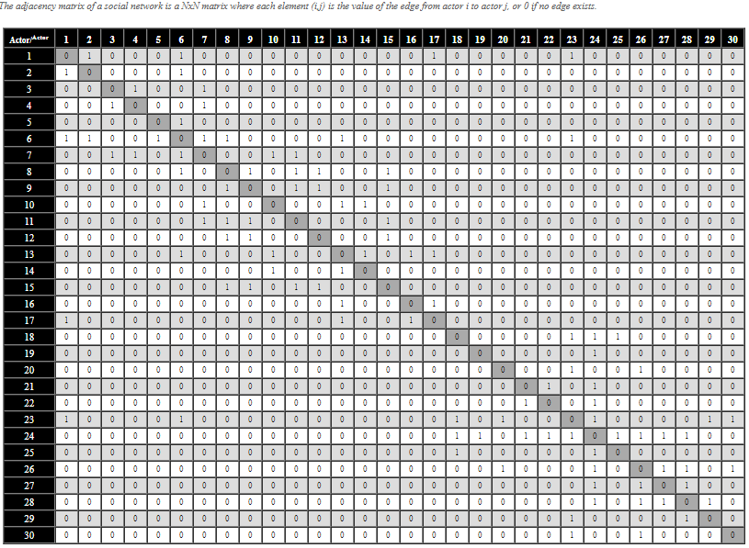

1. A discussion on the workings of the network
2. The density of the network
3. The points centrality of the network

**Degree centrality**

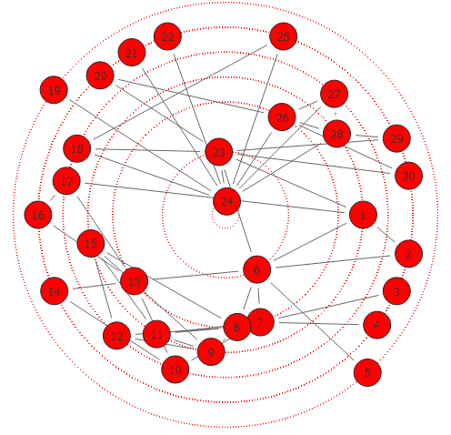

**Closeness**

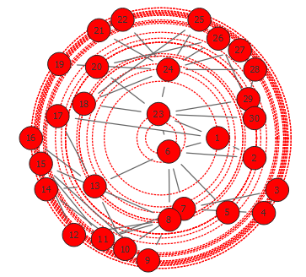

**Betweenness**

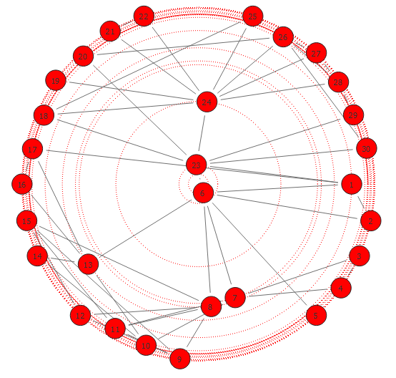

1. A discussion of the components of the network, cliques stars, brokers, and influencers etc.